**COURIER MANAGEMENT SYSTEM**

**COURIER**

**MANAGEMENT SYSTEM**



**CERTIFICATE**

This is to certify that the students

* **M TAUSEEF QASMI** Student 1525507
* **ZAIN** Student 1511317
* **M JAZIM NOOR** Student 1512406
* **ZEESHAN** Student 1510739

Of batch **PR2-202308C1** have successfully completed the given task for the topic

**FACULTY: MISS KINZA**

**SEMESTER**

**APTECH LEARNING SHAHRAH-E-FAISAL**

**ACKNOWLEDGEMENT**

We would like to express our sincere appreciation to all individuals and teams involved in the successful completion of this IT project. Their dedication, expertise, and collaborative efforts played a pivotal role in achieving our project goals. We extend our gratitude to everyone who contributed to the planning, development, testing, and implementation phases. This project's success is a testament to the hard work and commitment of each team member, and we acknowledge their valuable contributions. Thank you for your unwavering support and commitment to excellence.

We would also like to express our sincere gratitude to Aptech Learning Centre for providing us with the knowledge, resources, and support throughout our journey. The comprehensive curriculum and dedicated faculty member Sir Faiz Ali have played a pivotal role in shaping our understanding of the dynamic field of information technology and which have undoubtedly equipped us for success in the ever-evolving world of technology.

**WHAT IS THIS E-PROJECT?**

E-Project is a step-by-step learning environment that closely simulates the classroom and Lab based learning environment into actual implementation. It is a project implementation at your fingertips. An electronic, live juncture on the machine that allows you to

* Practice step by step i.e. laddered approach.
* Build a larger more robust application.
* Usage of certain utilities in applications designed by user.
* Single program to unified code leading to a complete application.
* Learn implementation of concepts in a phased manner.
* Enhance skills and add value.
* Work on real life projects.
* Give a real life scenario and help to create applications more complicated and useful.
* Mentoring through email support.

**PROBLEM STATEMENT**

Problem statement is attached separately in a file “Courier Management System”

**Standards plan:**

Every code block must have comments.

The logic of the program needs to be explained. Proper documentation

should be maintained.

Complete Project Report along with synopsis, code and documentation should

be prepared.

**Documentation:**

No project is complete without documentation. In fact, it is one of the most

important activities during the development of a project. The documentation

of an ideal project will be in the form of a project report comprising of the

following documents:

* Certificate of Completion.
* Table of Contents.
* Problem Definition.
* Customer Requirement Specification.
* Project Plan.
* E-R Diagrams.
* Algorithms.
* ➢ GUI Standards Document.
* ➢ Interface Design Document.
* ➢ Task Sheet.
* ➢ Project Review and Monitoring Report.
* ➢ Unit Testing Check List.
* ➢ Final Check List.

**C M S**



This application is about courier management system in which three types of user.

1. Admin.
2. Agent.
3. User.

**PROJECT ANALYSIS**

|  |  |  |  |
| --- | --- | --- | --- |
| NAME | ADMIN  PANNEL | AGENT  PANNEL | USER  PANNEL |
| M. TAUSEEF QASMI | Checkmark | Checkmark | Checkmark |
| ZAIN |  |  | Checkmark |
| M JAZIM NOOR |  |  | Checkmark |
| ZEESHAN |  |  | Checkmark |

**USER MANUAL**

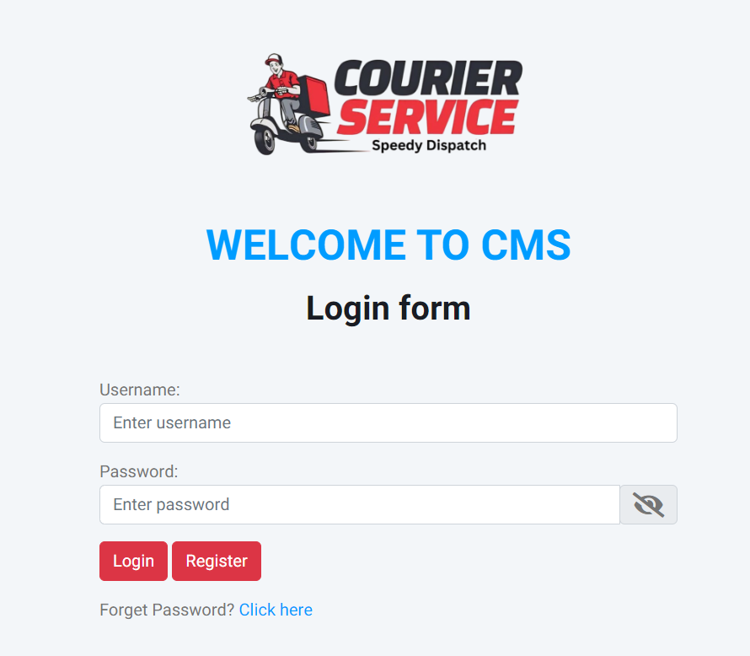

* This is login page from where admin agent or user can login

**Admin Dashboard**

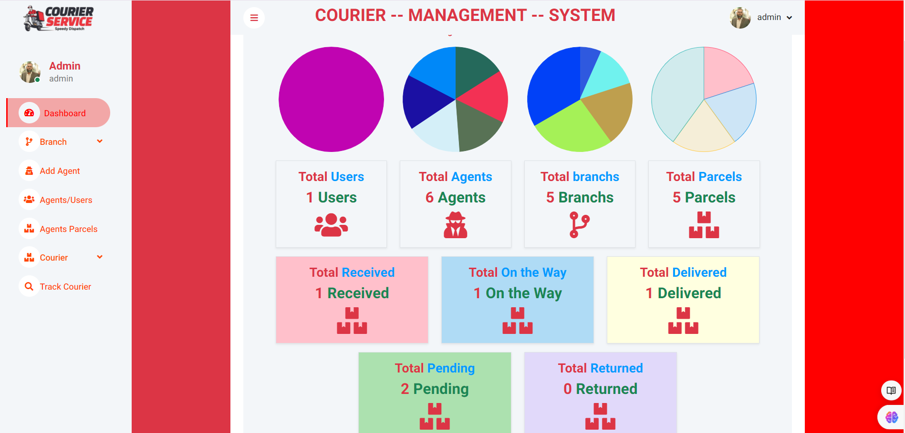

This is admin login page from where on dashboard admin can check all number of users, agents, branches and parcels. Also admin can check the status of parcels.

**Add agent**

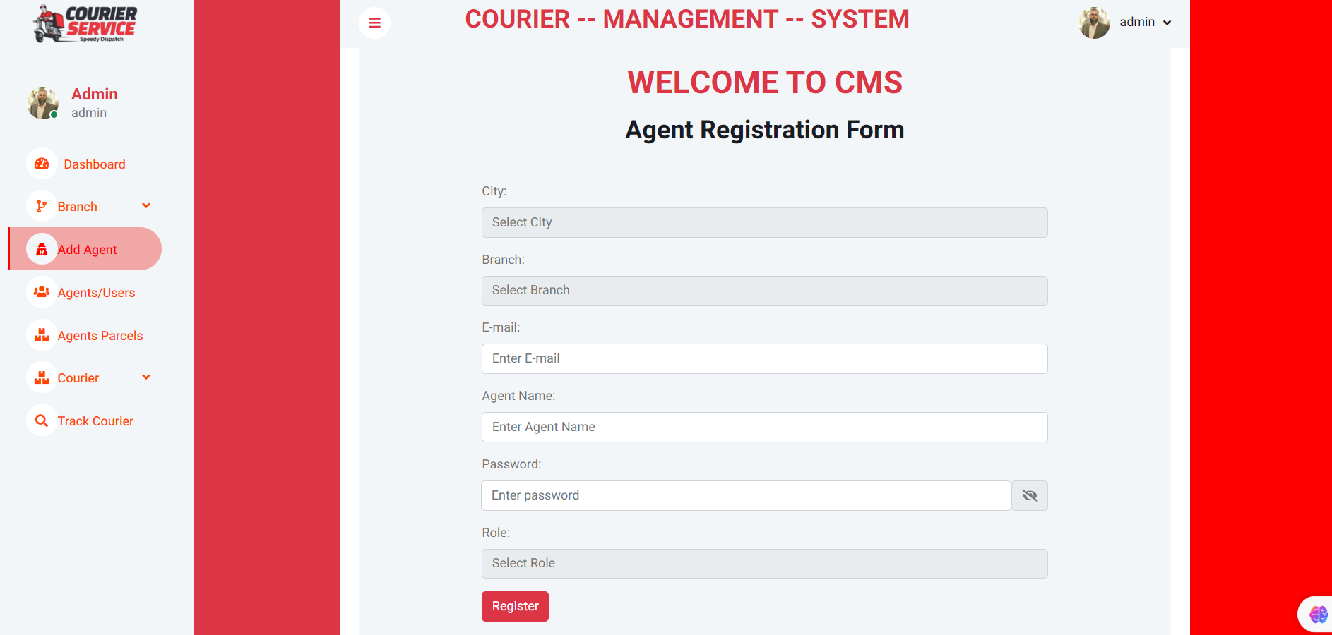

Through this page admin can add agent with specific city and branch .

**Add Branch**

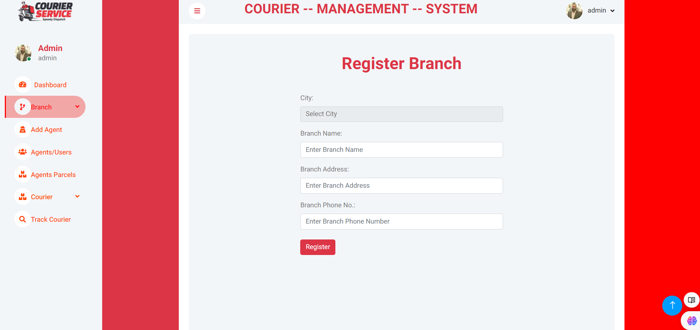

From this page admin can add branch of specific city.

**View Branch**

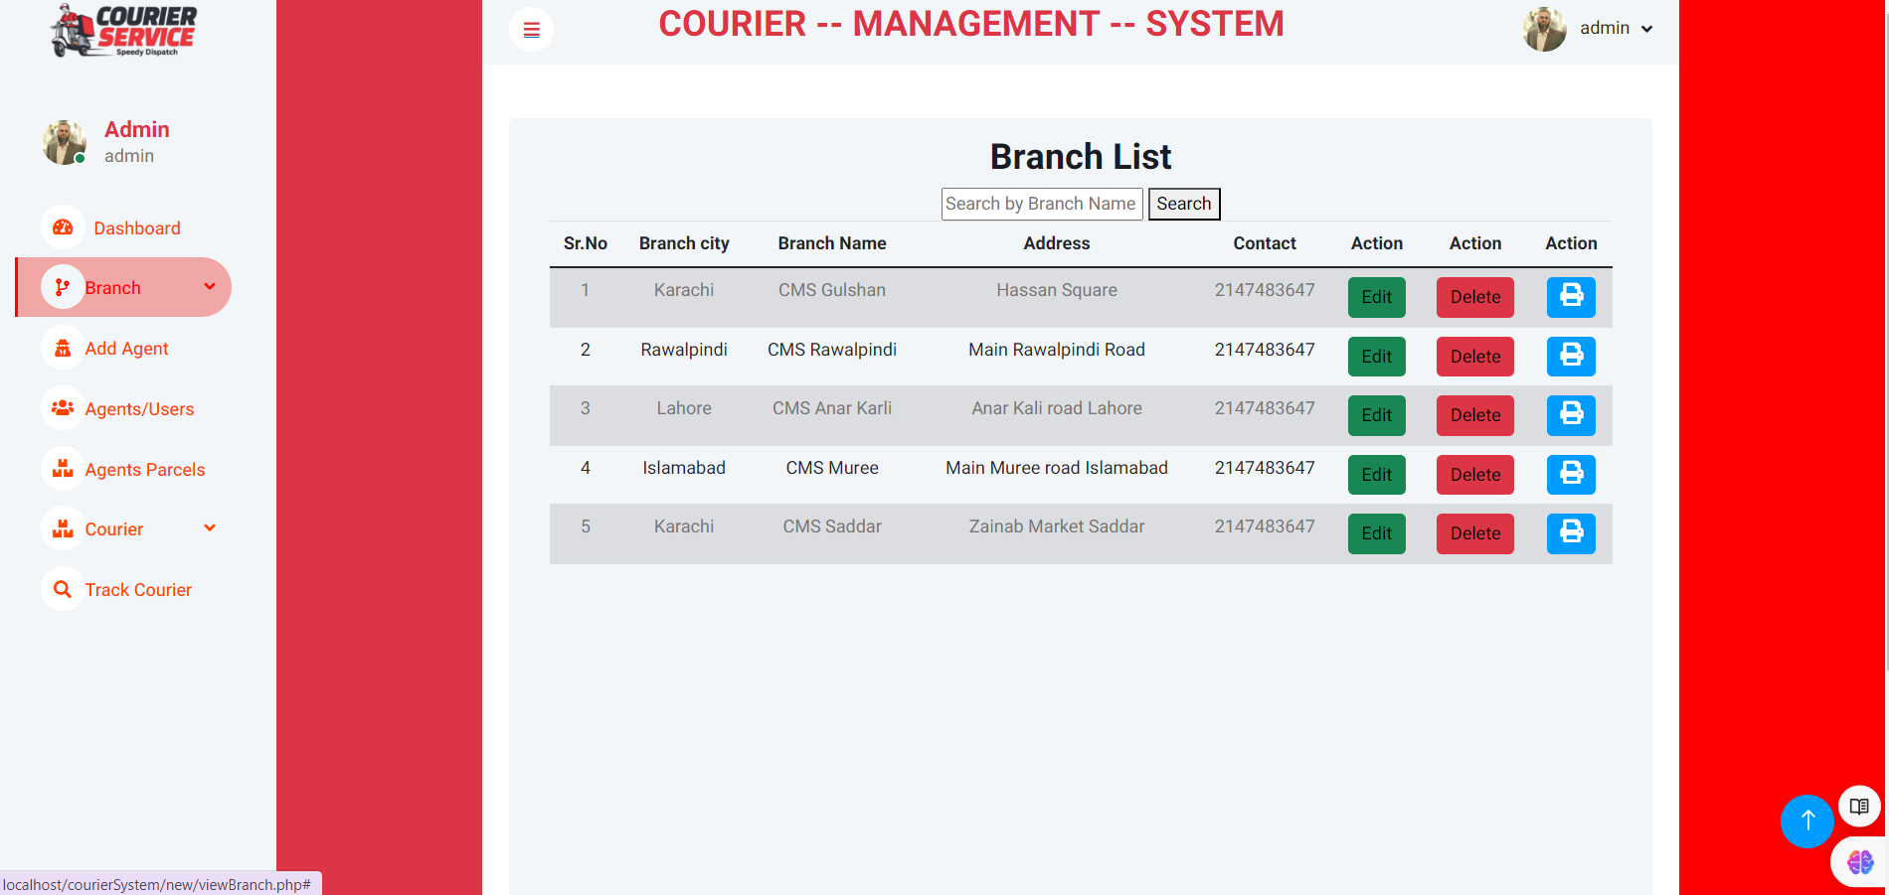

From this page admin can check the number of branches and also if admin wants any update branch or delete branch.

**City wise branches**

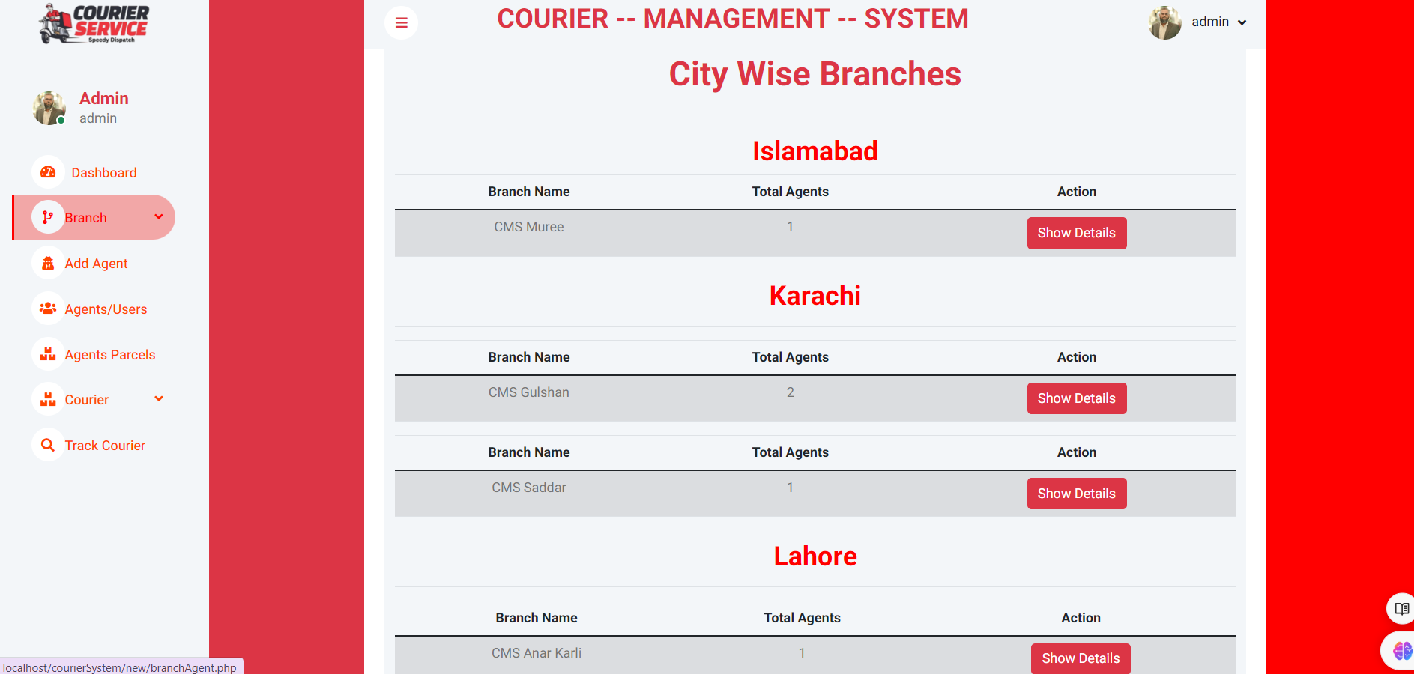

From this admin can check city wise branches and its agents. On click show details all agents will display with their all parcels with status wise

**Add agent**

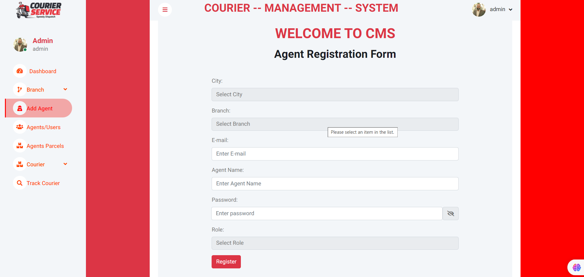

From this page admin can add agent with specific city and branch.

**Check parcels**

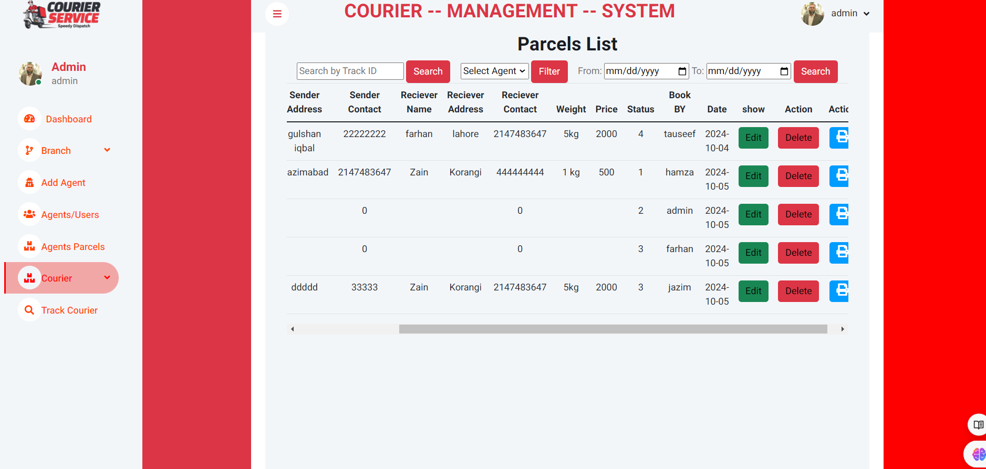

From this page admin can check all parcels with its complete detail. Admin can search parcel by tracking id or by agent name or by date wise .

**Track Courier**

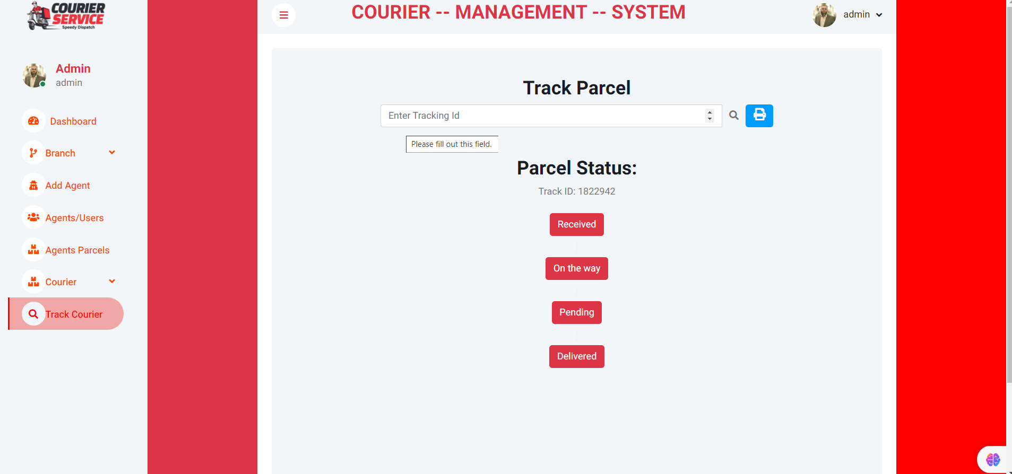

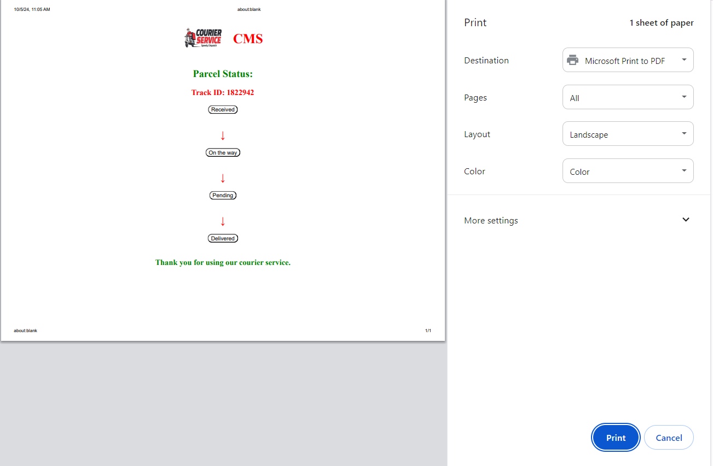

Through this page admin can track parcel id and check its status and also print the status

**Agent dashboard**

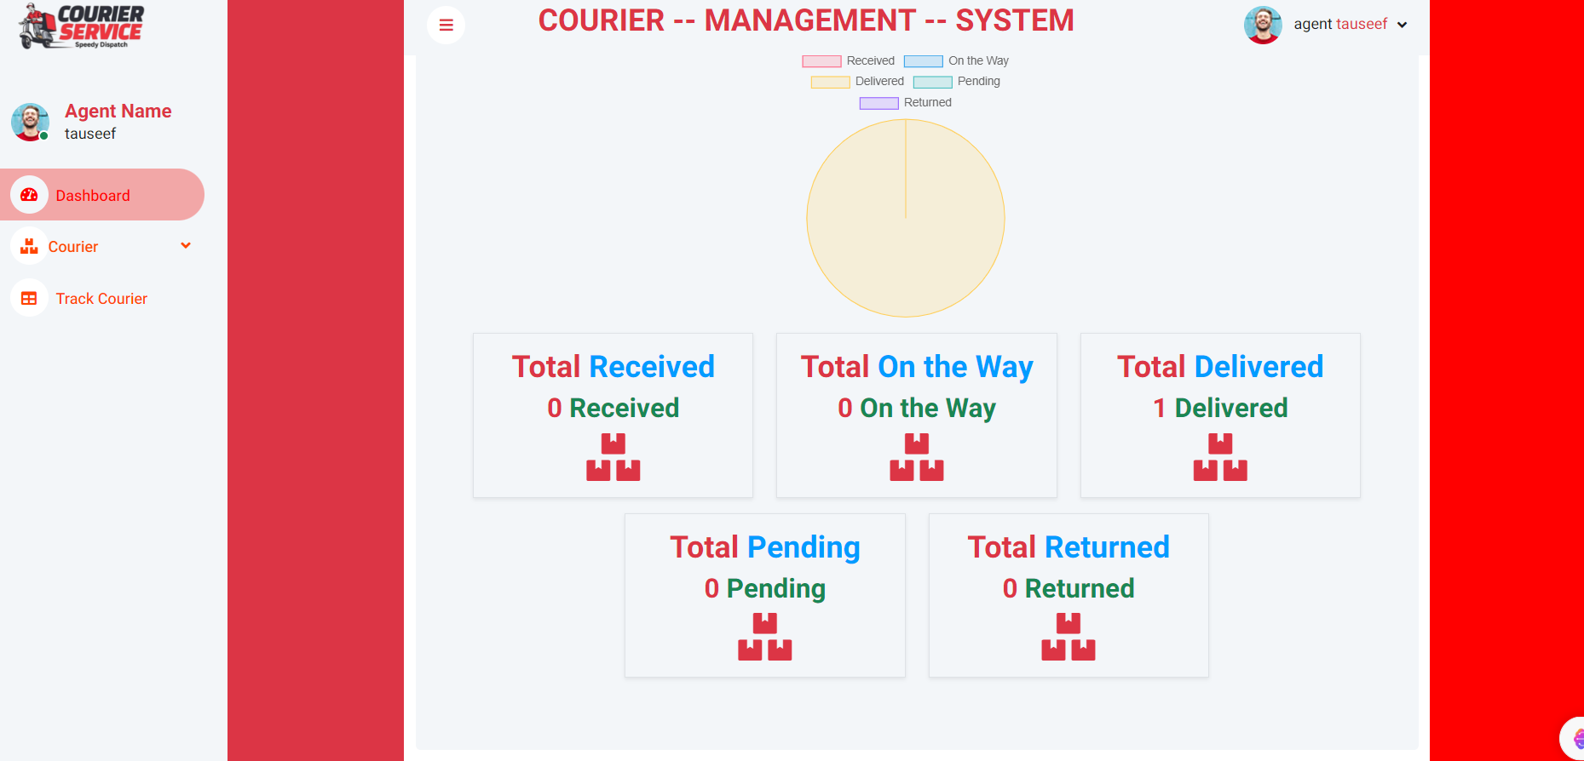

This is agent dashboard every agent have its own dashboard and agent only see their parcels details.

**Agent Add Courier**

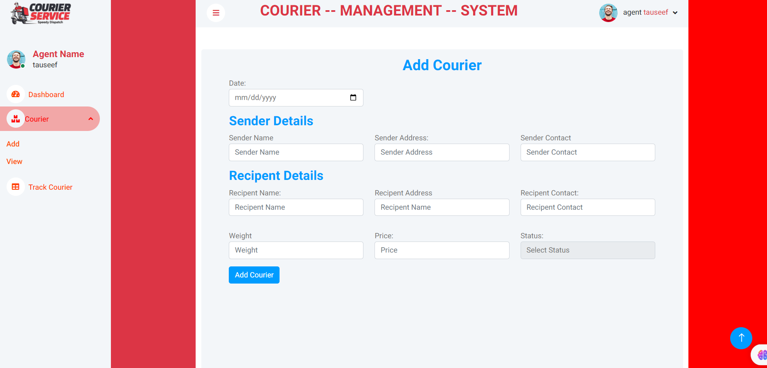

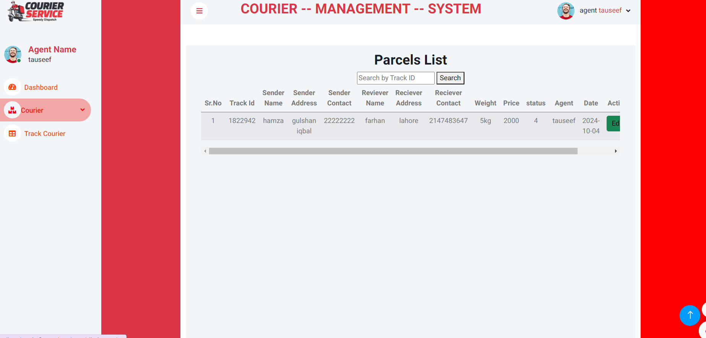

Agent can add courier and see its detail and update status.

Track Courier

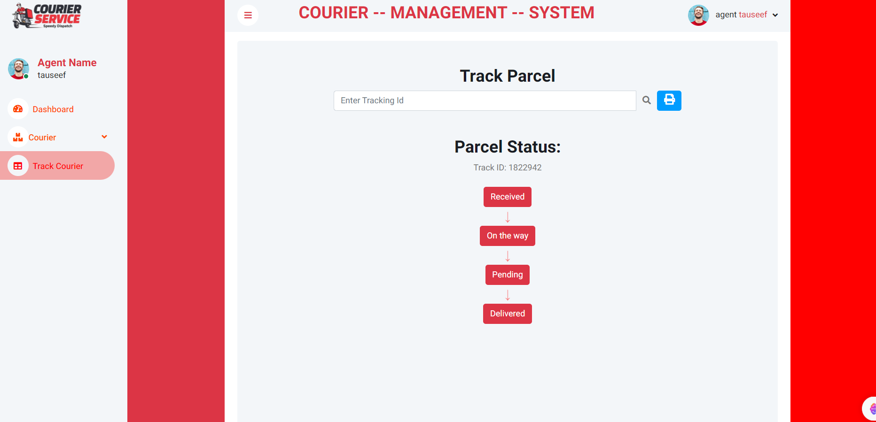



Through this page agent can track parcel id and check its status and also print the status

**User Dashboard**

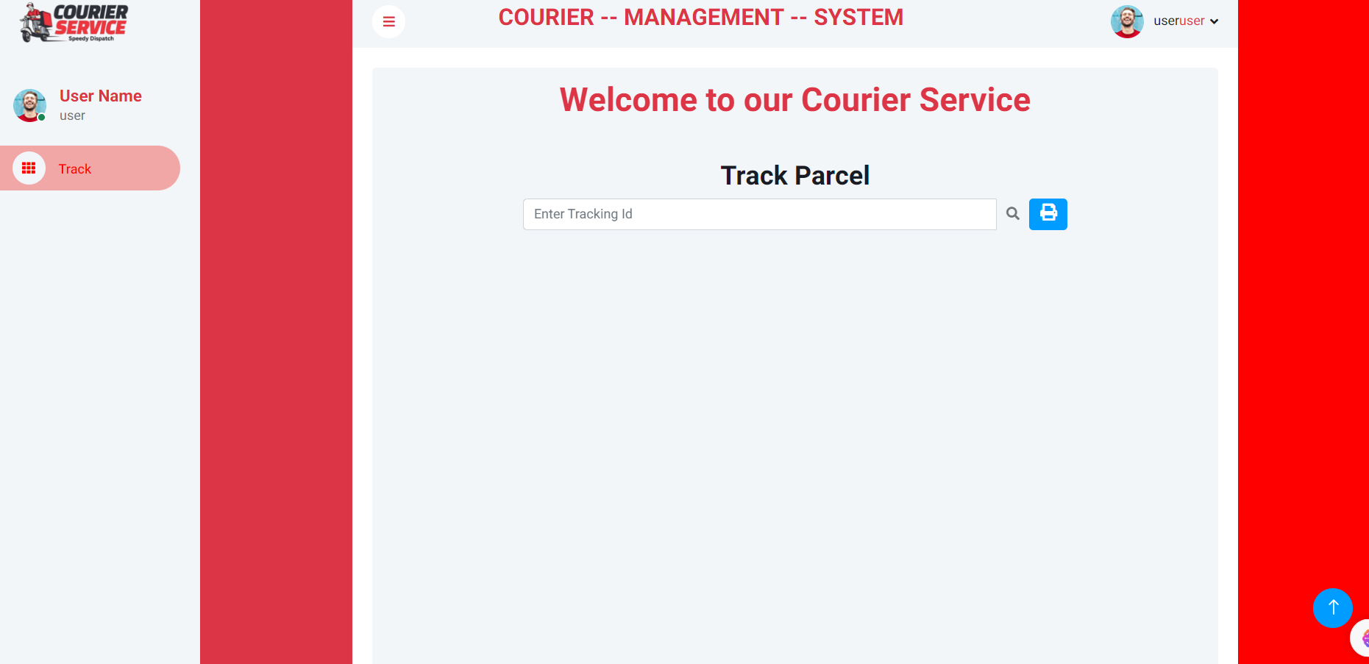



This is user dashboard page

Through this page user can track parcel id and check its status and also print the status

**Database Diagram**

